**ASSIGNMENT 10.5**

**Problem Statement:**

* Write a pig script to find the top 20 destination people travel the most: Based on the given data.
* Write a pig script to find the top 20 locations from where people travel the most.

**Input (DATA SET):**

The data set can be downloaded from the link below:

Travel_Data

**Data Set Description:**

**Travel Sector Dataset Description**

Column 1: City pair (Combination of *from* and *to*): String

Column 2: From location: String

Column 3: To Location: String

Column 4: Product type: Integer (1=Air, 2=Car, 3 =Air+Car, 4 =Hotel,

5=Air+Hotel, 6=Hotel +Car, 7 =Air+Hotel+Car)

Column 5: Adults traveling: Integer

Column 6: Seniors traveling: Integer

Column 7: Children traveling: Integer

Column 8: Youth traveling: Integer

Column 9: Infant traveling: Integer

Column 10: Date of travel: String

Column 11: Time of travel: String

Column 12: Date of Return: String

Column 13: Time of Return: String

Column 14: Price of booking: Float

Column 15: Hotel name: String

**Program:**

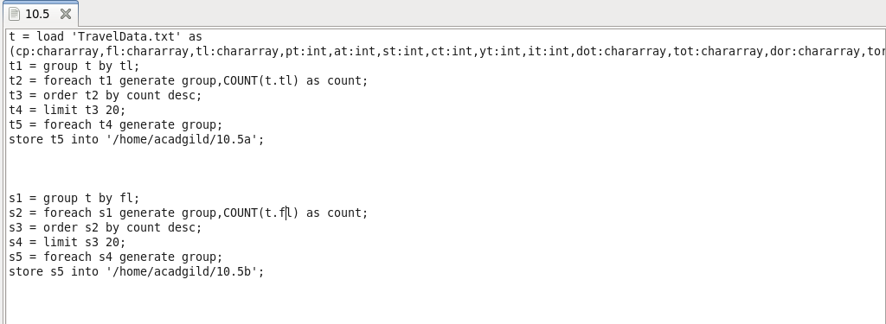

**Output:**

